# Gravity Modelling–Forward Modelling Using Real Data

**After completing this practical you should be able to:**

The aim of this practical is to use **forward modelling** as a tool for interpreting geophysical anomalies determined for real geological examples. We will do this by implementing a forward model (using Excel) which predicts the Bouguer gravity anomaly for a spherical object of specified density (relative to surrounding rock), depth and size (radius). We will use **standard statistical tests** to quantify how well, or not, a particular model fits a set of observed data.

After completing this practical you should be able to:

• Use Excel to perform complex calculations multiple times using formulae.

• Use the spherical forward model to predict the gravity anomaly measured at the surface generated by a buried spherical object of any size, density or depth.

• Be able to use this simple forward model to estimate the physical and geological parameters of an object consistent with the measured gravity anomaly across that object.

• Use standard statistics such as the mean, standard deviation and root mean square deviation to assess the “goodness of fit” between model predictions and observations.

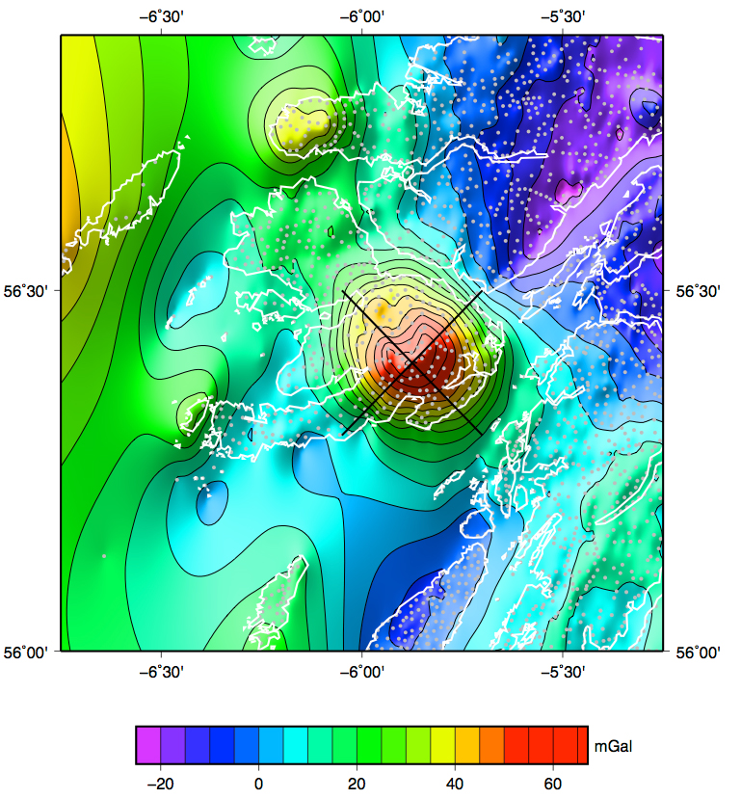

**Fig. 1.** Bouguer gravity anomaly map for the Isle of Mull. The two transects from which data are extracted for this lab are shown by black lines.

**Task 1.**

Download the Mull gravity traverse data from Moodle. Note that there are 2 transects, one oriented NE-SW and one NW-SE (see Fig. 1). For each transect calculate the Free Air anomaly and the Bouguer anomaly by applying the standard gravity corrections (as you did in Lab 1). Note that for these data there is a Terrain Correction term (provided in the data set). This should be added to your calculated Bouguer anomaly values.

Lets, for now, assume that the gravity anomaly can be approximated by a single composite intrusion located beneath the centre of the main complex in the SE of the island. Use a simple model for a buried spherical body to estimate the radius, depth and average density of this body that is consistent with the observed **Bouguer gravity anomaly**. Ensure you determine the “goodness of fit” between your model and the data using appropriate statistical methods (e.g. assess distribution of residuals and RMSD vs mean Std. Dev. Of measurements).

In this case we will have to use simple observations of the surface geology to help constrain our model input parameters. The likely radius of any subsurface igneous body is probably between 8 to 12 km (see map below)? Use your geological knowledge, the geological map and table of rock densities (see below) to decide on a reasonable range of values for the density contrast (e.g. gabbro intruding granite could be one end member?).



**Fig. 2** Simplified geological map of the Isle of Mull.

Compare your results and conclusions with the study by Bott and Tantrigoda (1987). This is a study that used a more sophisticated model, but arguably with no major gain in sophistication of the conclusions (compared with yours)?

Bott, M.H.P. and Tantrigoda, D.A. 1987, Interpretation of the gravity and magnetic anomalies over the Mull intrusive complex, NW Scotland, *Journal of the Geological Society*, London, v. **144**, p. 17-28.

**Task 2.**

A paper by Donato et al. (1983) (data and pdf version of paper available on Moodle) reported the results of a gravity study of an area in the North Sea. The authors have demonstrated that the Bouguer anomaly profile along their section B-B’ (Figure 7 in paper & below) is reasonably well matched by a conceptual model of a conical shaped granite body with a centre of mass located at roughly 7-8 km depth and a half width of roughly 6-8 km and a density contrast of **negative** 0.09 g.cm-3. Using your spherical model assess how well the observed data can be matched by the Bouguer anomaly predicted for a simple spherical shaped granite body, and determine the radius, depth and (assuming a density contrast of -0.09 g.cm-3).

Perform a **statistical assessment** of how well your model fits the observations by determining the **Root Mean Square Deviation** between your model and the observations. Refer to statistical notes from Lab 2 as required.



Donato, J.A., Martindale, W. and Tully, M.C., 1983, Buried granites within the Mid North Sea High, *Journal of the Geological Society*, v. **140**, p. 825-837.

**Table 1. Typical rock densities**

|  |  |
| --- | --- |
| **Rock Type** | **Density Range**  **(g.cm-3)** |
| Andesite | 2.5 - 2.8 |
| Basalt | 2.8 - 3.0 |
| Coal | 1.1 - 1.4 |
| Diabase | 2.6 - 3.0 |
| Diorite | 2.8 - 3.0 |
| Dolomite | 2.8 - 2.9 |
| Gabbro | 2.7 - 3.3 |
| Gneiss | 2.6 - 2.9 |
| Granite | 2.6 - 2.7 |
| Gypsum | 2.3 - 2.8 |
| Limestone | 2.3 - 2.7 |
| Marble | 2.4 - 2.7 |
| Mica schist | 2.5 - 2.9 |
| Peridotite | 3.1 - 3.4 |
| Quartzite | 2.6 - 2.8 |
| Rhyolite | 2.4 - 2.6 |
| Rock salt | 2.5 - 2.6 |
| Sandstone | 2.2 - 2.8 |
| Shale | 2.4 - 2.8 |
| Slate | 2.7 - 2.8 |